**PROGRAM: (Caesar Cipher)**

**#include <stdio.h>**

**#include <string.h>**

**#include<conio.h>**

**#include <ctype.h>**

**void main(){**

**char plain[10], cipher[10];**

**int key,i,length;**

**int result;**

**clrscr();**

**printf("\n Enter the plain text:");**

**scanf("%s", plain);**

**printf("\n Enter the key value:");**

**scanf("%d", &key);**

**printf("\n \n \t PLAIN TEXt: %s",plain);**

**printf("\n \n \t ENCRYPTED TEXT: ");**

**for(i = 0, length = strlen(plain); i < length; i++)**

**{**

**cipher[i]=plain[i] + key;**

**if (isupper(plain[i]) && (cipher[i] > 'Z'))**

**cipher[i] = cipher[i] - 26;**

**if (islower(plain[i]) && (cipher[i] > 'z'))**

**cipher[i] = cipher[i] - 26;**

**printf("%c", cipher[i]);**

**}**

**printf("\n \n \t AFTER DECRYPTION : ");**

**for(i=0;i<length;i++)**

**{**

**plain[i]=cipher[i]-key;**

**if(isupper(cipher[i])&&(plain[i]<'A'))**

**plain[i]=plain[i]+26;**

**if(islower(cipher[i])&&(plain[i]<'a'))**

**plain[i]=plain[i]+26;**

**printf("%c",plain[i]);**

**}**

**getch();**

**}**

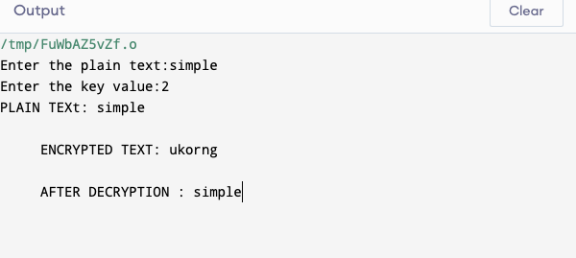

**PROGRAM: (Playfair Cipher)**

#include<stdio.h>

//#include<conio.h>

#include<string.h>

#include<ctype.h>

#define MX 5

void playfair(char ch1,char ch2, char key[MX][MX])

{

int i,j,w,x,y,z;

FILE *out;

if((out=fopen("cipher.txt","a+"))==NULL)

{

printf("File Currupted.");

}

for(i=0;i<MX;i++)

{

for(j=0;j<MX;j++)

{

if(ch1==key[i][j])

{

w=i;

x=j;

}

else if(ch2==key[i][j])

{

y=i;

z=j;

}}}

//printf("%d%d %d%d",w,x,y,z);

if(w==y)

{

x=(x+1)%5;z=(z+1)%5;

printf("%c%c",key[w][x],key[y][z]);

fprintf(out, "%c%c",key[w][x],key[y][z]);

}

else if(x==z)

{ w=(w+1)%5;y=(y+1)%5;

printf("%c%c",key[w][x],key[y][z]);

fprintf(out, "%c%c",key[w][x],key[y][z]);

}

else

{

printf("%c%c",key[w][z],key[y][x]);

fprintf(out, "%c%c",key[w][z],key[y][x]);

}

fclose(out);

}

void main()

{

int i,j,k=0,l,m=0,n;

char key[MX][MX],keyminus[25],keystr[10],str[25]={0};

char

alpa[26]={'A','B','C','D','E','F','G','H','I','J','K','L'

,'M','N','O','P','Q','R','S','T','U','V','W','X','Y','Z'}

;

//clrscr();

printf("\nEnter key:");

gets(keystr);

printf("\nEnter the plain text:");

gets(str);

n=strlen(keystr);

//convert the characters to uppertext

for (i=0; i<n; i++)

{

if(keystr[i]=='j')keystr[i]='i';

else if(keystr[i]=='J')keystr[i]='I';

keystr[i] = toupper(keystr[i]);

}

//convert all the characters of plaintext to uppertext

for (i=0; i<strlen(str); i++)

{

if(str[i]=='j')str[i]='i';

else if(str[i]=='J')str[i]='I';

str[i] = toupper(str[i]);

}

j=0;

for(i=0;i<26;i++)

{

for(k=0;k<n;k++)

{

if(keystr[k]==alpa[i])

break;

else if(alpa[i]=='J')

break;

}

if(k==n)

{

keyminus[j]=alpa[i];j++;

} }//construct key keymatrix

k=0;

for(i=0;i<MX;i++)

{

for(j=0;j<MX;j++)

{

if(k<n)

{

key[i][j]=keystr[k];

k++;}

else

{

key[i][j]=keyminus[m];m++;

}

printf("%c ",key[i][j]);

}

printf("\n");

}

printf("\n\nEntered text :%s\nCipher Text :",str);

for(i=0;i<strlen(str);i++)

{

if(str[i]=='J')str[i]='I';

if(str[i+1]=='\0')

playfair(str[i],'X',key);

else

{}

//getch();

}

if(str[i+1]=='J')str[i+1]='I';

if(str[i]==str[i+1])

playfair(str[i],'X',key);

else

{

playfair(str[i],str[i+1],key);i++;

}}

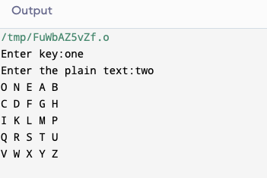

**PROGRAM: (Hill Cipher)**

#include<stdio.h>

//#include<conio.h>

#include<string.h>

int main(){

unsigned int a[3][3]={{6,24,1},{13,16,10},{20,17,15}};

unsigned int b[3][3]={{8,5,10},{21,8,21},{21,12,8}};

int i,j, t=0;

unsigned int c[20],d[20];

char msg[20];

//clrscr();

printf("Enter plain text\n ");

scanf("%s",msg);

for(i=0;i<strlen(msg);i++)

{ c[i]=msg[i]-65;printf("%d ",c[i]);

}

for(i=0;i<3;i++)

{ t=0;

for(j=0;j<3;j++)

{

t=t+(a[i][j]*c[j]);

}

d[i]=t%26;

}

printf("\nEncrypted Cipher Text :");

for(i=0;i<3;i++)

printf(" %c",d[i]+65);

for(i=0;i<3;i++)

{

t=0;

for(j=0;j<3;j++)

{

t=t+(b[i][j]*d[j]);

}

c[i]=t%26;

}

printf("\nDecrypted Cipher Text :");

for(i=0;i<3;i++)

printf(" %c",c[i]+65);

//getch();

return 0;

}

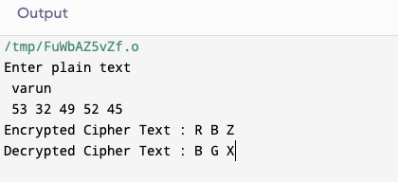

**PROGRAM: (Vigenere Cipher)**

#include <stdio.h>

//#include<conio.h>

#include <ctype.h>

#include <string.h>

void encipher();

void decipher();

void main()

{

int choice;

//clrscr();

while(1)

{

printf("\n1. Encrypt Text");

printf("\t2. Decrypt Text");

printf("\t3. Exit");

printf("\n\nEnter Your Choice : ");

scanf("%d",&choice);

if(choice == 3)

exit(0);

else if(choice == 1)

encipher();

else if(choice == 2)

decipher();

else

printf("Please Enter Valid Option.");

} }

void encipher()

{

unsigned int i,j;

char input[50],key[10];

printf("\n\nEnter Plain Text: ");

scanf("%s",input);

printf("\nEnter Key Value: ");

scanf("%s",key);

printf("\nResultant Cipher Text: ");

for(i=0,j=0;i<strlen(input);i++,j++)

{

if(j>=strlen(key))

{ j=0;

}

printf("%c",65+(((toupper(input[i])-65)+(toupper(key[j])-

65))%26));

}}

void decipher()

{

unsigned int i,j;

char input[50],key[10];

int value;

printf("\n\nEnter Cipher Text: ");

scanf("%s",input);

printf("\n\nEnter the key value: ");

scanf("%s",key);

for(i=0,j=0;i<strlen(input);i++,j++)

{

if(j>=strlen(key))

{ j=0; }

value = (toupper(input[i])-64)-(toupper(key[j])-64);

if( value < 0)

{ value = value * -1;

}

printf("%c",65 + (value % 26));

}}

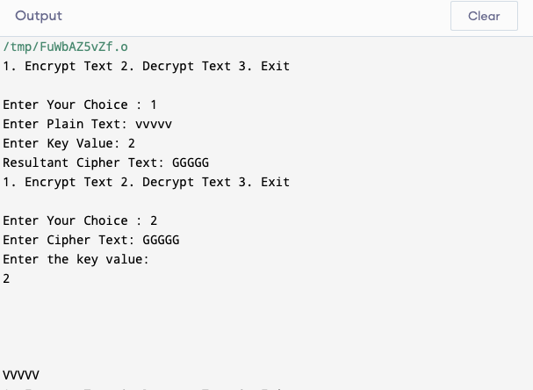

**PROGRAM: (Rail Fence)**

#include<stdio.h>

//#include<conio.h>

#include<string.h>

void main()

{

int i,j,k,l;

char a[20],c[20],d[20];

//clrscr();

printf("\n\t\t RAIL FENCE TECHNIQUE");

printf("\n\nEnter the input string : ");

gets(a);

l=strlen(a);

/*Ciphering*/

for(i=0,j=0;i<l;i++)

{

if(i%2==0)

c[j++]=a[i];

}

for(i=0;i<l;i++)

{

if(i%2==1)

c[j++]=a[i];

}

c[j]='\0';

printf("\nCipher text after applying rail fence :");

printf("\n%s",c);

/*Deciphering*/

if(l%2==0)

k=l/2;

else

k=(l/2)+1;

for(i=0,j=0;i<k;i++)

{

d[j]=c[i];

j=j+2;

}

for(i=k,j=1;i<l;i++)

{

d[j]=c[i];

j=j+2;

}

d[l]='\0';

printf("\nText after decryption : ");

printf("%s",d);

//getch();

}

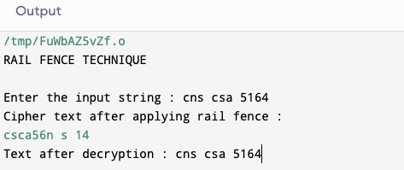

**PROGRAM: (RSA)**

#include<stdio.h>

//#include<conio.h>

#include<stdlib.h>

#include<math.h>

#include<string.h>

long int

p,q,n,t,flag,e[100],d[100],temp[100],j,m[100],en[100],i;

char msg[100];

int prime(long int);

void ce();

long int cd(long int);

void encrypt();

void decrypt();

void main()

{

//clrscr();

printf("\nENTER FIRST PRIME NUMBER\n");

scanf("%d",&p);

flag=prime(p);

if(flag==0)

{

printf("\nWRONG INPUT\n");

//getch();

}

printf("\nENTER ANOTHER PRIME NUMBER\n");

scanf("%d",&q);

flag=prime(q);

if(flag==0||p==q)

{

printf("\nWRONG INPUT\n");

//getch();

}

printf("\nENTER MESSAGE\n");

fflush(stdin);

scanf("%s",msg);

for(i=0;msg[i]!=NULL;i++)

m[i]=msg[i];

n=p*q;

t=(p-1)*(q-1);

ce();

printf("\nPOSSIBLE VALUES OF e AND d ARE\n");

for(i=0;i<j-1;i++)

printf("\n%ld\t%ld",e[i],d[i]);

encrypt();

decrypt();

//getch();

}

int prime(long int pr)

{

int i;

j=sqrt(pr);

for(i=2;i<=j;i++)

{

if(pr%i==0)

return 0;

}

return 1;

}

void ce()

{

int k;

k=0;

for(i=2;i<t;i++)

{

if(t%i==0)

continue;

flag=prime(i);

if(flag==1&&i!=p&&i!=q)

{

e[k]=i;

flag=cd(e[k]);

if(flag>0)

{

d[k]=flag;

k++;

}

if(k==99)

break;

} } }

long int cd(long int x)

{

long int k=1;

while(1)

{

k=k+t;

if(k%x==0)

return(k/x);

} }

void encrypt() {

long int pt,ct,key=e[0],k,len;

i=0;

len=strlen(msg);

while(i!=len) {

pt=m[i];

pt=pt-96;

k=1;

for(j=0;j<key;j++)

{ k=k*pt;

k=k%n;

}

temp[i]=k;

ct=k+96;

en[i]=ct;

i++;

}

en[i]=-1;

printf("\nTHE ENCRYPTED MESSAGE IS\n");

for(i=0;en[i]!=-1;i++)

printf("%c",en[i]);

}

void decrypt()

{

long int pt,ct,key=d[0],k;

i=0;

while(en[i]!=-1)

{

ct=temp[i];

k=1;

for(j=0;j<key;j++)

{

k=k*ct;

k=k%n;

}

pt=k+96;

m[i]=pt;

i++;

}

m[i]=-1;

printf("\nTHE DECRYPTED MESSAGE IS\n");

for(i=0;m[i]!=-1;i++)

printf("%c",m[i]);

}

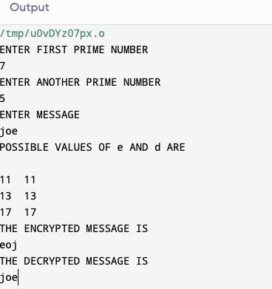

**PROGRAM: (Diffie Hellman Key Exchange)**

**#include<stdio.h>**

**//#include<conio.h>**

**long long int power(int a, int b, int mod)**

**{**

**long long int t;**

**if(b==1)**

**return a;**

**t=power(a,b/2,mod);**

**if(b%2==0)**

**return (t*t)%mod;**

**else**

**return (((t*t)%mod)*a)%mod;**

**}**

**long int calculateKey(int a, int x, int n)**

**{**

**return power(a,x,n);**

**}**

**void main()**

**{**

**int n,g,x,a,y,b;**

**//clrscr();**

**printf("Enter the value of n and g : ");**

**scanf("%d%d",&n,&g);**

**printf("Enter the value of x for the first person : ");**

**scanf("%d",&x);**

**a=power(g,x,n);**

**printf("Enter the value of y for the second person : ");**

**scanf("%d",&y);**

**b=power(g,y,n);**

**printf("key for the first person is :%lld\n",power(b,x,n));**

**printf("key for the second person is :%lld\n",power(a,y,n));**

**//getch();**

**}**

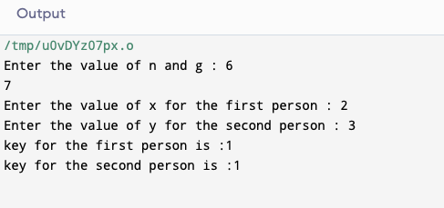

Program(md5):

#include <stdlib.h>

#include <stdio.h>

#include <string.h>

#include <math.h>

//#include<conio.h>

typedef union uwb

{

unsigned w;

unsigned char b[4];

} MD5union;

typedef unsigned DigestArray[4];

unsigned func0( unsigned abcd[] ){

return ( abcd[1] & abcd[2]) | (~abcd[1] & abcd[3]);}

unsigned func1( unsigned abcd[] ){

return ( abcd[3] & abcd[1]) | (~abcd[3] & abcd[2]);}

unsigned func2( unsigned abcd[] ){

return abcd[1] ^ abcd[2] ^ abcd[3];}

unsigned func3( unsigned abcd[] ){

return abcd[2] ^ (abcd[1] |~ abcd[3]);}

typedef unsigned (*DgstFctn)(unsigned a[]);

unsigned *calctable( unsigned *k)

{

double s, pwr;

int i;

pwr = pow( 2, 32);

for (i=0; i<64; i++)

{

s = fabs(sin(1+i));

k[i] = (unsigned)( s * pwr );

}

return k;

}

unsigned rol( unsigned r, short N )

{

unsigned mask1 = (1<<N) -1;

return ((r>>(32-N)) & mask1) | ((r<<N) & ~mask1);

}

unsigned *md5( const char *msg, int mlen)

{

static DigestArray h0 = { 0x67452301, 0xEFCDAB89,

0x98BADCFE, 0x10325476 };

static DgstFctn ff[] = { &func0, &func1, &func2, &func3};

static short M[] = { 1, 5, 3, 7 };

static short O[] = { 0, 1, 5, 0 };

static short rot0[] = { 7,12,17,22};

static short rot1[] = { 5, 9,14,20};

static short rot2[] = { 4,11,16,23};

static short rot3[] = { 6,10,15,21};

static short *rots[] = {rot0, rot1, rot2, rot3 };

static unsigned kspace[64];

static unsigned *k;

static DigestArray h;

DigestArray abcd;

DgstFctn fctn;

short m, o, g;

unsigned f;

short *rotn;

union

{

unsigned w[16];

char b[64];

}mm;

int os = 0;

int grp, grps, q, p;

unsigned char *msg2;

if (k==NULL) k= calctable(kspace);

for (q=0; q<4; q++) h[q] = h0[q]; // initialize

{

grps = 1 + (mlen+8)/64;

msg2 = malloc( 64* grps);

memcpy( msg2, msg, mlen);

msg2[mlen] = (unsigned char)0x80;

q = mlen + 1;

while (q < 64*grps){ msg2[q] = 0; q++ ; }

{

MD5union u;

u.w = 8*mlen;

q -= 8;

memcpy(msg2+q, &u.w, 4 );

}

}

for (grp=0; grp<grps; grp++)

{

memcpy( mm.b, msg2+os, 64);

for(q=0;q<4;q++) abcd[q] = h[q];

for (p = 0; p<4; p++)

{

fctn = ff[p];

rotn = rots[p];

m = M[p]; o= O[p];

for (q=0; q<16; q++)

{

g = (m*q + o) % 16;

f = abcd[1] + rol( abcd[0]+ fctn(abcd)+k[q+16*p]+ mm.w[g], rotn[q%4]);

abcd[0] = abcd[3];

abcd[3] = abcd[2];

abcd[2] = abcd[1];

abcd[1] = f;

}}

for (p=0; p<4; p++)

h[p] += abcd[p];

os += 64;

}

return h;}

int main()

{

int j,k;

const char *msg = "The quick brown fox jumps over the lazy dog";

unsigned *d = md5(msg, strlen(msg));

MD5union u;

printf("\t MD5 ENCRYPTION ALGORITHM IN C \n\n");

printf("Input String to be Encrypted using MD5 :\n\t%s",msg);

printf("\n\nThe MD5 code for input string is: \n");

printf("\t= 0x");

for (j=0;j<4; j++){

u.w = d[j];

for (k=0;k<4;k++) printf("%02x",u.b[k]);

}

printf("\n");

printf("\n\t MD5 Encyption Successfully Completed!!!\n\n");

//getch();

system("pause");

//getch();

}

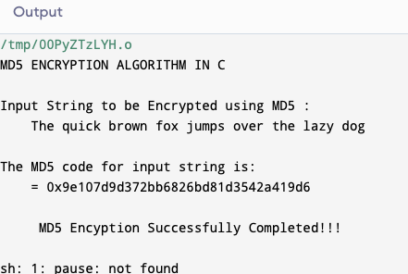

Program(des)

#include <bits/stdc++.h>

using namespace std;

string hex2bin(string s)

{

// hexadecimal to binary conversion

unordered_map<char, string> mp;

mp['0'] = "0000";

mp['1'] = "0001";

mp['2'] = "0010";

mp['3'] = "0011";

mp['4'] = "0100";

mp['5'] = "0101";

mp['6'] = "0110";

mp['7'] = "0111";

mp['8'] = "1000";

mp['9'] = "1001";

mp['A'] = "1010";

mp['B'] = "1011";

mp['C'] = "1100";

mp['D'] = "1101";

mp['E'] = "1110";

mp['F'] = "1111";

string bin = "";

for (int i = 0; i < s.size(); i++) {

bin += mp[s[i]];

}

return bin;

}

string bin2hex(string s)

{

// binary to hexadecimal conversion

unordered_map<string, string> mp;

mp["0000"] = "0";

mp["0001"] = "1";

mp["0010"] = "2";

mp["0011"] = "3";

mp["0100"] = "4";

mp["0101"] = "5";

mp["0110"] = "6";

mp["0111"] = "7";

mp["1000"] = "8";

mp["1001"] = "9";

mp["1010"] = "A";

mp["1011"] = "B";

mp["1100"] = "C";

mp["1101"] = "D";

mp["1110"] = "E";

mp["1111"] = "F";

string hex = "";

for (int i = 0; i < s.length(); i += 4) {

string ch = "";

ch += s[i];

ch += s[i + 1];

ch += s[i + 2];

ch += s[i + 3];

hex += mp[ch];

}

return hex;

}

string permute(string k, int* arr, int n)

{

string per = "";

for (int i = 0; i < n; i++) {

per += k[arr[i] - 1];

}

return per;

}

string shift_left(string k, int shifts)

{

string s = "";

for (int i = 0; i < shifts; i++) {

for (int j = 1; j < 28; j++) {

s += k[j];

}

s += k[0];

k = s;

s = "";

}

return k;

}

string xor_(string a, string b)

{

string ans = "";

for (int i = 0; i < a.size(); i++) {

if (a[i] == b[i]) {

ans += "0";

}

else {

ans += "1";

}

}

return ans;

}

string encrypt(string pt, vector<string> rkb,

vector<string> rk)

{

// Hexadecimal to binary

pt = hex2bin(pt);

// Initial Permutation Table

int initial_perm[64]

= { 58, 50, 42, 34, 26, 18, 10, 2, 60, 52, 44,

36, 28, 20, 12, 4, 62, 54, 46, 38, 30, 22,

14, 6, 64, 56, 48, 40, 32, 24, 16, 8, 57,

49, 41, 33, 25, 17, 9, 1, 59, 51, 43, 35,

27, 19, 11, 3, 61, 53, 45, 37, 29, 21, 13,

5, 63, 55, 47, 39, 31, 23, 15, 7 };

// Initial Permutation

pt = permute(pt, initial_perm, 64);

cout << "After initial permutation: " << bin2hex(pt)

<< endl;

// Splitting

string left = pt.substr(0, 32);

string right = pt.substr(32, 32);

cout << "After splitting: L0=" << bin2hex(left)

<< " R0=" << bin2hex(right) << endl;

// Expansion D-box Table

int exp_d[48]

= { 32, 1, 2, 3, 4, 5, 4, 5, 6, 7, 8, 9,

8, 9, 10, 11, 12, 13, 12, 13, 14, 15, 16, 17,

16, 17, 18, 19, 20, 21, 20, 21, 22, 23, 24, 25,

24, 25, 26, 27, 28, 29, 28, 29, 30, 31, 32, 1 };

// S-box Table

int s[8][4][16] = {

{ 14, 4, 13, 1, 2, 15, 11, 8, 3, 10, 6, 12, 5,

9, 0, 7, 0, 15, 7, 4, 14, 2, 13, 1, 10, 6,

12, 11, 9, 5, 3, 8, 4, 1, 14, 8, 13, 6, 2,

11, 15, 12, 9, 7, 3, 10, 5, 0, 15, 12, 8, 2,

4, 9, 1, 7, 5, 11, 3, 14, 10, 0, 6, 13 },

{ 15, 1, 8, 14, 6, 11, 3, 4, 9, 7, 2, 13, 12,

0, 5, 10, 3, 13, 4, 7, 15, 2, 8, 14, 12, 0,

1, 10, 6, 9, 11, 5, 0, 14, 7, 11, 10, 4, 13,

1, 5, 8, 12, 6, 9, 3, 2, 15, 13, 8, 10, 1,

3, 15, 4, 2, 11, 6, 7, 12, 0, 5, 14, 9 },

{ 10, 0, 9, 14, 6, 3, 15, 5, 1, 13, 12,

7, 11, 4, 2, 8, 13, 7, 0, 9, 3, 4,

6, 10, 2, 8, 5, 14, 12, 11, 15, 1, 13,

6, 4, 9, 8, 15, 3, 0, 11, 1, 2, 12,

5, 10, 14, 7, 1, 10, 13, 0, 6, 9, 8,

7, 4, 15, 14, 3, 11, 5, 2, 12 },

{ 7, 13, 14, 3, 0, 6, 9, 10, 1, 2, 8, 5, 11,

12, 4, 15, 13, 8, 11, 5, 6, 15, 0, 3, 4, 7,

2, 12, 1, 10, 14, 9, 10, 6, 9, 0, 12, 11, 7,

13, 15, 1, 3, 14, 5, 2, 8, 4, 3, 15, 0, 6,

10, 1, 13, 8, 9, 4, 5, 11, 12, 7, 2, 14 },

{ 2, 12, 4, 1, 7, 10, 11, 6, 8, 5, 3, 15, 13,

0, 14, 9, 14, 11, 2, 12, 4, 7, 13, 1, 5, 0,

15, 10, 3, 9, 8, 6, 4, 2, 1, 11, 10, 13, 7,

8, 15, 9, 12, 5, 6, 3, 0, 14, 11, 8, 12, 7,

1, 14, 2, 13, 6, 15, 0, 9, 10, 4, 5, 3 },

{ 12, 1, 10, 15, 9, 2, 6, 8, 0, 13, 3, 4, 14,

7, 5, 11, 10, 15, 4, 2, 7, 12, 9, 5, 6, 1,

13, 14, 0, 11, 3, 8, 9, 14, 15, 5, 2, 8, 12,

3, 7, 0, 4, 10, 1, 13, 11, 6, 4, 3, 2, 12,

9, 5, 15, 10, 11, 14, 1, 7, 6, 0, 8, 13 },

{ 4, 11, 2, 14, 15, 0, 8, 13, 3, 12, 9, 7, 5,

10, 6, 1, 13, 0, 11, 7, 4, 9, 1, 10, 14, 3,

5, 12, 2, 15, 8, 6, 1, 4, 11, 13, 12, 3, 7,

14, 10, 15, 6, 8, 0, 5, 9, 2, 6, 11, 13, 8,

1, 4, 10, 7, 9, 5, 0, 15, 14, 2, 3, 12 },

{ 13, 2, 8, 4, 6, 15, 11, 1, 10, 9, 3, 14, 5,

0, 12, 7, 1, 15, 13, 8, 10, 3, 7, 4, 12, 5,

6, 11, 0, 14, 9, 2, 7, 11, 4, 1, 9, 12, 14,

2, 0, 6, 10, 13, 15, 3, 5, 8, 2, 1, 14, 7,

4, 10, 8, 13, 15, 12, 9, 0, 3, 5, 6, 11 }

};

// Straight Permutation Table

int per[32]

= { 16, 7, 20, 21, 29, 12, 28, 17, 1, 15, 23,

26, 5, 18, 31, 10, 2, 8, 24, 14, 32, 27,

3, 9, 19, 13, 30, 6, 22, 11, 4, 25 };

cout << endl;

for (int i = 0; i < 16; i++) {

// Expansion D-box

string right_expanded = permute(right, exp_d, 48);

// XOR RoundKey[i] and right_expanded

string x = xor_(rkb[i], right_expanded);

// S-boxes

string op = "";

for (int i = 0; i < 8; i++) {

int row = 2 * int(x[i * 6] - '0')

+ int(x[i * 6 + 5] - '0');

int col = 8 * int(x[i * 6 + 1] - '0')

+ 4 * int(x[i * 6 + 2] - '0')

+ 2 * int(x[i * 6 + 3] - '0')

+ int(x[i * 6 + 4] - '0');

int val = s[i][row][col];

op += char(val / 8 + '0');

val = val % 8;

op += char(val / 4 + '0');

val = val % 4;

op += char(val / 2 + '0');

val = val % 2;

op += char(val + '0');

}

// Straight D-box

op = permute(op, per, 32);

// XOR left and op

x = xor_(op, left);

left = x;

// Swapper

if (i != 15) {

swap(left, right);

}

cout << "Round " << i + 1 << " " << bin2hex(left)

<< " " << bin2hex(right) << " " << rk[i]

<< endl;

}

// Combination

string combine = left + right;

// Final Permutation Table

int final_perm[64]

= { 40, 8, 48, 16, 56, 24, 64, 32, 39, 7, 47,

15, 55, 23, 63, 31, 38, 6, 46, 14, 54, 22,

62, 30, 37, 5, 45, 13, 53, 21, 61, 29, 36,

4, 44, 12, 52, 20, 60, 28, 35, 3, 43, 11,

51, 19, 59, 27, 34, 2, 42, 10, 50, 18, 58,

26, 33, 1, 41, 9, 49, 17, 57, 25 };

// Final Permutation

string cipher

= bin2hex(permute(combine, final_perm, 64));

return cipher;

}

// Driver code

int main()

{

// pt is plain text

string pt, key;

/*cout<<"Enter plain text(in hexadecimal): ";

cin>>pt;

cout<<"Enter key(in hexadecimal): ";

cin>>key;*/

pt = "123456ABCD132536";

key = "AABB09182736CCDD";

// Key Generation

// Hex to binary

key = hex2bin(key);

// Parity bit drop table

int keyp[56]

= { 57, 49, 41, 33, 25, 17, 9, 1, 58, 50, 42, 34,

26, 18, 10, 2, 59, 51, 43, 35, 27, 19, 11, 3,

60, 52, 44, 36, 63, 55, 47, 39, 31, 23, 15, 7,

62, 54, 46, 38, 30, 22, 14, 6, 61, 53, 45, 37,

29, 21, 13, 5, 28, 20, 12, 4 };

// getting 56 bit key from 64 bit using the parity bits

key = permute(key, keyp, 56); // key without parity

// Number of bit shifts

int shift_table[16] = { 1, 1, 2, 2, 2, 2, 2, 2,

1, 2, 2, 2, 2, 2, 2, 1 };

// Key- Compression Table

int key_comp[48] = { 14, 17, 11, 24, 1, 5, 3, 28,

15, 6, 21, 10, 23, 19, 12, 4,

26, 8, 16, 7, 27, 20, 13, 2,

41, 52, 31, 37, 47, 55, 30, 40,

51, 45, 33, 48, 44, 49, 39, 56,

34, 53, 46, 42, 50, 36, 29, 32 };

// Splitting

string left = key.substr(0, 28);

string right = key.substr(28, 28);

vector<string> rkb; // rkb for RoundKeys in binary

vector<string> rk; // rk for RoundKeys in hexadecimal

for (int i = 0; i < 16; i++) {

// Shifting

left = shift_left(left, shift_table[i]);

right = shift_left(right, shift_table[i]);

// Combining

string combine = left + right;

// Key Compression

string RoundKey = permute(combine, key_comp, 48);

rkb.push_back(RoundKey);

rk.push_back(bin2hex(RoundKey));

}

cout << "\nEncryption:\n\n";

string cipher = encrypt(pt, rkb, rk);

cout << "\nCipher Text: " << cipher << endl;

cout << "\nDecryption\n\n";

reverse(rkb.begin(), rkb.end());

reverse(rk.begin(), rk.end());

string text = encrypt(cipher, rkb, rk);

cout << "\nPlain Text: " << text << endl;

}

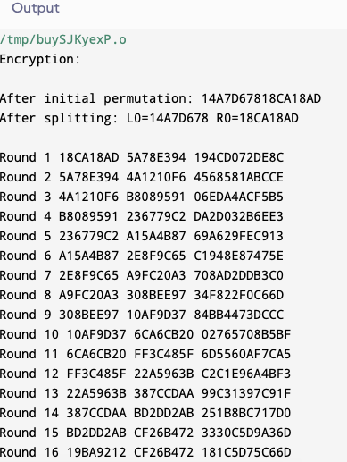

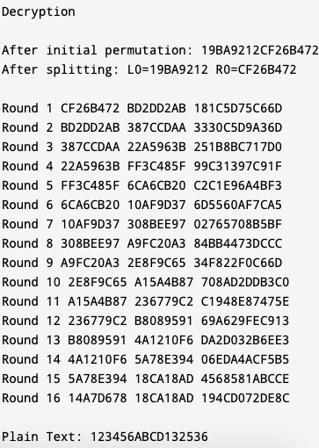

Program(dsa)

#include <stdio.h>

#include <string.h>

static void display(int intArray[], int length){

int i=0;

printf("Array : [");

for(i = 0; i < length; i++) {

/* display value of element at index i. */

printf(" %d ", intArray[i]);

}

printf(" ]\n ");

}

int main() {

int i = 0;

/* Declare an array */

int intArray[8];

// initialize elements of array n to 0

for ( i = 0; i < 8; i++ ) {

intArray[ i ] = 0; // set elements to default value of 0;

}

printf("Array with default data.");

/* Display elements of an array.*/

display(intArray,8);

/* Operation : Insertion

Add elements in the array */

for(i = 0; i < 8; i++) {

/* place value of i at index i. */

printf("Adding %d at index %d\n",i,i);

intArray[i] = i;

}

printf("\n");

printf("Array after adding data. ");

display(intArray,8);

/* Operation : Insertion

Element at any location can be updated directly */

int index = 5;

intArray[index] = 10;

printf("Array after updating element at index %d.\n",index);

display(intArray,8);

/* Operation : Search using index

Search an element using index.*/

printf("Data at index %d:%d\n" ,index,intArray[index]);

/* Operation : Search using value

Search an element using value.*/

int value = 4;

for(i = 0; i < 8; i++) {

if(intArray[i] == value ){

printf("value %d Found at index %d \n", intArray[i],i);

break;

}

}

return 0;

}

Output:

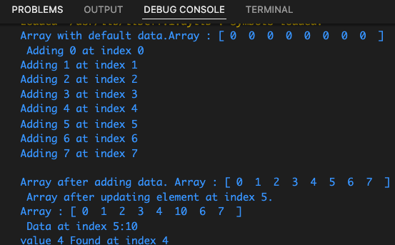

Sha program (python):

import hashlib

str = "varun"

result = hashlib.sha256(str.encode())

print("The hexadecimal equivalent of SHA256 is : ")

print(result.hexdigest())

print ("\r")

str = "varun"

result = hashlib.sha384(str.encode())

print("The hexadecimal equivalent of SHA384 is : ")

print(result.hexdigest())

print ("\r")

str = "varun"

result = hashlib.sha224(str.encode())

print("The hexadecimal equivalent of SHA224 is : ")

print(result.hexdigest())

print ("\r")

str = "varun"

result = hashlib.sha512(str.encode())

print("The hexadecimal equivalent of SHA512 is : ")

print(result.hexdigest())

print ("\r")

str = "varun"

result = hashlib.sha1(str.encode())

print("The hexadecimal equivalent of SHA1 is : ")

print(result.hexdigest())

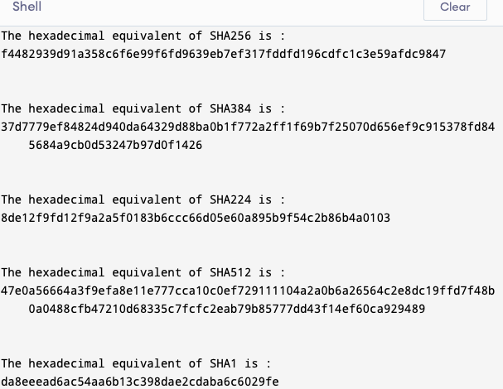

Blowfish(python):

p = [

0x243F6A88, 0x85A308D3, 0x13198A2E, 0x03707344,

0xA4093822, 0x299F31D0, 0x082EFA98, 0xEC4E6C89,

0x452821E6, 0x38D01377, 0xBE5466CF, 0x34E90C6C,

0xC0AC29B7, 0xC97C50DD, 0x3F84D5B5, 0xB5470917,

0x9216D5D9, 0x8979FB1B

]

s = [

[

0xD1310BA6, 0x98DFB5AC, 0x2FFD72DB, 0xD01ADFB7,

0xB8E1AFED, 0x6A267E96, 0xBA7C9045, 0xF12C7F99,

0x24A19947, 0xB3916CF7, 0x0801F2E2, 0x858EFC16,

0x636920D8, 0x71574E69, 0xA458FEA3, 0xF4933D7E,

0x0D95748F, 0x728EB658, 0x718BCD58, 0x82154AEE,

0x7B54A41D, 0xC25A59B5, 0x9C30D539, 0x2AF26013,

0xC5D1B023, 0x286085F0, 0xCA417918, 0xB8DB38EF,

0x8E79DCB0, 0x603A180E, 0x6C9E0E8B, 0xB01E8A3E,

0xD71577C1, 0xBD314B27, 0x78AF2FDA, 0x55605C60,

0xE65525F3, 0xAA55AB94, 0x57489862, 0x63E81440,

0x55CA396A, 0x2AAB10B6, 0xB4CC5C34, 0x1141E8CE,

0xA15486AF, 0x7C72E993, 0xB3EE1411, 0x636FBC2A,

0x2BA9C55D, 0x741831F6, 0xCE5C3E16, 0x9B87931E,

0xAFD6BA33, 0x6C24CF5C, 0x7A325381, 0x28958677,

0x3B8F4898, 0x6B4BB9AF, 0xC4BFE81B, 0x66282193,

0x61D809CC, 0xFB21A991, 0x487CAC60, 0x5DEC8032,

0xEF845D5D, 0xE98575B1, 0xDC262302, 0xEB651B88,

0x23893E81, 0xD396ACC5, 0x0F6D6FF3, 0x83F44239,

0x2E0B4482, 0xA4842004, 0x69C8F04A, 0x9E1F9B5E,

0x21C66842, 0xF6E96C9A, 0x670C9C61, 0xABD388F0,

0x6A51A0D2, 0xD8542F68, 0x960FA728, 0xAB5133A3,

0x6EEF0B6C, 0x137A3BE4, 0xBA3BF050, 0x7EFB2A98,

0xA1F1651D, 0x39AF0176, 0x66CA593E, 0x82430E88,

0x8CEE8619, 0x456F9FB4, 0x7D84A5C3, 0x3B8B5EBE,

0xE06F75D8, 0x85C12073, 0x401A449F, 0x56C16AA6,

0x4ED3AA62, 0x363F7706, 0x1BFEDF72, 0x429B023D,

0x37D0D724, 0xD00A1248, 0xDB0FEAD3, 0x49F1C09B,

0x075372C9, 0x80991B7B, 0x25D479D8, 0xF6E8DEF7,

0xE3FE501A, 0xB6794C3B, 0x976CE0BD, 0x04C006BA,

0xC1A94FB6, 0x409F60C4, 0x5E5C9EC2, 0x196A2463,

0x68FB6FAF, 0x3E6C53B5, 0x1339B2EB, 0x3B52EC6F,

0x6DFC511F, 0x9B30952C, 0xCC814544, 0xAF5EBD09,

0xBEE3D004, 0xDE334AFD, 0x660F2807, 0x192E4BB3,

0xC0CBA857, 0x45C8740F, 0xD20B5F39, 0xB9D3FBDB,

0x5579C0BD, 0x1A60320A, 0xD6A100C6, 0x402C7279,

0x679F25FE, 0xFB1FA3CC, 0x8EA5E9F8, 0xDB3222F8,

0x3C7516DF, 0xFD616B15, 0x2F501EC8, 0xAD0552AB,

0x323DB5FA, 0xFD238760, 0x53317B48, 0x3E00DF82,

0x9E5C57BB, 0xCA6F8CA0, 0x1A87562E, 0xDF1769DB,

0xD542A8F6, 0x287EFFC3, 0xAC6732C6, 0x8C4F5573,

0x695B27B0, 0xBBCA58C8, 0xE1FFA35D, 0xB8F011A0,

0x10FA3D98, 0xFD2183B8, 0x4AFCB56C, 0x2DD1D35B,

0x9A53E479, 0xB6F84565, 0xD28E49BC, 0x4BFB9790,

0xE1DDF2DA, 0xA4CB7E33, 0x62FB1341, 0xCEE4C6E8,

0xEF20CADA, 0x36774C01, 0xD07E9EFE, 0x2BF11FB4,

0x95DBDA4D, 0xAE909198, 0xEAAD8E71, 0x6B93D5A0,

0xD08ED1D0, 0xAFC725E0, 0x8E3C5B2F, 0x8E7594B7,

0x8FF6E2FB, 0xF2122B64, 0x8888B812, 0x900DF01C,

0x4FAD5EA0, 0x688FC31C, 0xD1CFF191, 0xB3A8C1AD,

0x2F2F2218, 0xBE0E1777, 0xEA752DFE, 0x8B021FA1,

0xE5A0CC0F, 0xB56F74E8, 0x18ACF3D6, 0xCE89E299,

0xB4A84FE0, 0xFD13E0B7, 0x7CC43B81, 0xD2ADA8D9,

0x165FA266, 0x80957705, 0x93CC7314, 0x211A1477,

0xE6AD2065, 0x77B5FA86, 0xC75442F5, 0xFB9D35CF,

0xEBCDAF0C, 0x7B3E89A0, 0xD6411BD3, 0xAE1E7E49,

0x00250E2D, 0x2071B35E, 0x226800BB, 0x57B8E0AF,

0x2464369B, 0xF009B91E, 0x5563911D, 0x59DFA6AA,

0x78C14389, 0xD95A537F, 0x207D5BA2, 0x02E5B9C5,

0x83260376, 0x6295CFA9, 0x11C81968, 0x4E734A41,

0xB3472DCA, 0x7B14A94A, 0x1B510052, 0x9A532915,

0xD60F573F, 0xBC9BC6E4, 0x2B60A476, 0x81E67400,

0x08BA6FB5, 0x571BE91F, 0xF296EC6B, 0x2A0DD915,

0xB6636521, 0xE7B9F9B6, 0xFF34052E, 0xC5855664,

0x53B02D5D, 0xA99F8FA1, 0x08BA4799, 0x6E85076A

],

[

0x4B7A70E9, 0xB5B32944, 0xDB75092E, 0xC4192623,

0xAD6EA6B0, 0x49A7DF7D, 0x9CEE60B8, 0x8FEDB266,

0xECAA8C71, 0x699A17FF, 0x5664526C, 0xC2B19EE1,

0x193602A5, 0x75094C29, 0xA0591340, 0xE4183A3E,

0x3F54989A, 0x5B429D65, 0x6B8FE4D6, 0x99F73FD6,

0xA1D29C07, 0xEFE830F5, 0x4D2D38E6, 0xF0255DC1,

0x4CDD2086, 0x8470EB26, 0x6382E9C6, 0x021ECC5E,

0x09686B3F, 0x3EBAEFC9, 0x3C971814, 0x6B6A70A1,

0x687F3584, 0x52A0E286, 0xB79C5305, 0xAA500737,

0x3E07841C, 0x7FDEAE5C, 0x8E7D44EC, 0x5716F2B8,

0xB03ADA37, 0xF0500C0D, 0xF01C1F04, 0x0200B3FF,

0xAE0CF51A, 0x3CB574B2, 0x25837A58, 0xDC0921BD,

0xD19113F9, 0x7CA92FF6, 0x94324773, 0x22F54701,

0x3AE5E581, 0x37C2DADC, 0xC8B57634, 0x9AF3DDA7,

0xA9446146, 0x0FD0030E, 0xECC8C73E, 0xA4751E41,

0xE238CD99, 0x3BEA0E2F, 0x3280BBA1, 0x183EB331,

0x4E548B38, 0x4F6DB908, 0x6F420D03, 0xF60A04BF,

0x2CB81290, 0x24977C79, 0x5679B072, 0xBCAF89AF,

0xDE9A771F, 0xD9930810, 0xB38BAE12, 0xDCCF3F2E,

0x5512721F, 0x2E6B7124, 0x501ADDE6, 0x9F84CD87,

0x7A584718, 0x7408DA17, 0xBC9F9ABC, 0xE94B7D8C,

0xEC7AEC3A, 0xDB851DFA, 0x63094366, 0xC464C3D2,

0xEF1C1847, 0x3215D908, 0xDD433B37, 0x24C2BA16,

0x12A14D43, 0x2A65C451, 0x50940002, 0x133AE4DD,

0x71DFF89E, 0x10314E55, 0x81AC77D6, 0x5F11199B,

0x043556F1, 0xD7A3C76B, 0x3C11183B, 0x5924A509,

0xF28FE6ED, 0x97F1FBFA, 0x9EBABF2C, 0x1E153C6E,

0x86E34570, 0xEAE96FB1, 0x860E5E0A, 0x5A3E2AB3,

0x771FE71C, 0x4E3D06FA, 0x2965DCB9, 0x99E71D0F,

0x803E89D6, 0x5266C825, 0x2E4CC978, 0x9C10B36A,

0xC6150EBA, 0x94E2EA78, 0xA5FC3C53, 0x1E0A2DF4,

0xF2F74EA7, 0x361D2B3D, 0x1939260F, 0x19C27960,

0x5223A708, 0xF71312B6, 0xEBADFE6E, 0xEAC31F66,

0xE3BC4595, 0xA67BC883, 0xB17F37D1, 0x018CFF28,

0xC332DDEF, 0xBE6C5AA5, 0x65582185, 0x68AB9802,

0xEECEA50F, 0xDB2F953B, 0x2AEF7DAD, 0x5B6E2F84,

0x1521B628, 0x29076170, 0xECDD4775, 0x619F1510,

0x13CCA830, 0xEB61BD96, 0x0334FE1E, 0xAA0363CF,

0xB5735C90, 0x4C70A239, 0xD59E9E0B, 0xCBAADE14,

0xEECC86BC, 0x60622CA7, 0x9CAB5CAB, 0xB2F3846E,

0x648B1EAF, 0x19BDF0CA, 0xA02369B9, 0x655ABB50,

0x40685A32, 0x3C2AB4B3, 0x319EE9D5, 0xC021B8F7,

0x9B540B19, 0x875FA099, 0x95F7997E, 0x623D7DA8,

0xF837889A, 0x97E32D77, 0x11ED935F, 0x16681281,

0x0E358829, 0xC7E61FD6, 0x96DEDFA1, 0x7858BA99,

0x57F584A5, 0x1B227263, 0x9B83C3FF, 0x1AC24696,

0xCDB30AEB, 0x532E3054, 0x8FD948E4, 0x6DBC3128,

0x58EBF2EF, 0x34C6FFEA, 0xFE28ED61, 0xEE7C3C73,

0x5D4A14D9, 0xE864B7E3, 0x42105D14, 0x203E13E0,

0x45EEE2B6, 0xA3AAABEA, 0xDB6C4F15, 0xFACB4FD0,

0xC742F442, 0xEF6ABBB5, 0x654F3B1D, 0x41CD2105,

0xD81E799E, 0x86854DC7, 0xE44B476A, 0x3D816250,

0xCF62A1F2, 0x5B8D2646, 0xFC8883A0, 0xC1C7B6A3,

0x7F1524C3, 0x69CB7492, 0x47848A0B, 0x5692B285,

0x095BBF00, 0xAD19489D, 0x1462B174, 0x23820E00,

0x58428D2A, 0x0C55F5EA, 0x1DADF43E, 0x233F7061,

0x3372F092, 0x8D937E41, 0xD65FECF1, 0x6C223BDB,

0x7CDE3759, 0xCBEE7460, 0x4085F2A7, 0xCE77326E,

0xA6078084, 0x19F8509E, 0xE8EFD855, 0x61D99735,

0xA969A7AA, 0xC50C06C2, 0x5A04ABFC, 0x800BCADC,

0x9E447A2E, 0xC3453484, 0xFDD56705, 0x0E1E9EC9,

0xDB73DBD3, 0x105588CD, 0x675FDA79, 0xE3674340,

0xC5C43465, 0x713E38D8, 0x3D28F89E, 0xF16DFF20,

0x153E21E7, 0x8FB03D4A, 0xE6E39F2B, 0xDB83ADF7

],

[

0xE93D5A68, 0x948140F7, 0xF64C261C, 0x94692934,

0x411520F7, 0x7602D4F7, 0xBCF46B2E, 0xD4A20068,

0xD4082471, 0x3320F46A, 0x43B7D4B7, 0x500061AF,

0x1E39F62E, 0x97244546, 0x14214F74, 0xBF8B8840,

0x4D95FC1D, 0x96B591AF, 0x70F4DDD3, 0x66A02F45,

0xBFBC09EC, 0x03BD9785, 0x7FAC6DD0, 0x31CB8504,

0x96EB27B3, 0x55FD3941, 0xDA2547E6, 0xABCA0A9A,

0x28507825, 0x530429F4, 0x0A2C86DA, 0xE9B66DFB,

0x68DC1462, 0xD7486900, 0x680EC0A4, 0x27A18DEE,

0x4F3FFEA2, 0xE887AD8C, 0xB58CE006, 0x7AF4D6B6,

0xAACE1E7C, 0xD3375FEC, 0xCE78A399, 0x406B2A42,

0x20FE9E35, 0xD9F385B9, 0xEE39D7AB, 0x3B124E8B,

0x1DC9FAF7, 0x4B6D1856, 0x26A36631, 0xEAE397B2,

0x3A6EFA74, 0xDD5B4332, 0x6841E7F7, 0xCA7820FB,

0xFB0AF54E, 0xD8FEB397, 0x454056AC, 0xBA489527,

0x55533A3A, 0x20838D87, 0xFE6BA9B7, 0xD096954B,

0x55A867BC, 0xA1159A58, 0xCCA92963, 0x99E1DB33,

0xA62A4A56, 0x3F3125F9, 0x5EF47E1C, 0x9029317C,

0xFDF8E802, 0x04272F70, 0x80BB155C, 0x05282CE3,

0x95C11548, 0xE4C66D22, 0x48C1133F, 0xC70F86DC,

0x07F9C9EE, 0x41041F0F, 0x404779A4, 0x5D886E17,

0x325F51EB, 0xD59BC0D1, 0xF2BCC18F, 0x41113564,

0x257B7834, 0x602A9C60, 0xDFF8E8A3, 0x1F636C1B,

0x0E12B4C2, 0x02E1329E, 0xAF664FD1, 0xCAD18115,

0x6B2395E0, 0x333E92E1, 0x3B240B62, 0xEEBEB922,

0x85B2A20E, 0xE6BA0D99, 0xDE720C8C, 0x2DA2F728,

0xD0127845, 0x95B794FD, 0x647D0862, 0xE7CCF5F0,

0x5449A36F, 0x877D48FA, 0xC39DFD27, 0xF33E8D1E,

0x0A476341, 0x992EFF74, 0x3A6F6EAB, 0xF4F8FD37,

0xA812DC60, 0xA1EBDDF8, 0x991BE14C, 0xDB6E6B0D,

0xC67B5510, 0x6D672C37, 0x2765D43B, 0xDCD0E804,

0xF1290DC7, 0xCC00FFA3, 0xB5390F92, 0x690FED0B,

0x667B9FFB, 0xCEDB7D9C, 0xA091CF0B, 0xD9155EA3,

0xBB132F88, 0x515BAD24, 0x7B9479BF, 0x763BD6EB,

0x37392EB3, 0xCC115979, 0x8026E297, 0xF42E312D,

0x6842ADA7, 0xC66A2B3B, 0x12754CCC, 0x782EF11C,

0x6A124237, 0xB79251E7, 0x06A1BBE6, 0x4BFB6350,

0x1A6B1018, 0x11CAEDFA, 0x3D25BDD8, 0xE2E1C3C9,

0x44421659, 0x0A121386, 0xD90CEC6E, 0xD5ABEA2A,

0x64AF674E, 0xDA86A85F, 0xBEBFE988, 0x64E4C3FE,

0x9DBC8057, 0xF0F7C086, 0x60787BF8, 0x6003604D,

0xD1FD8346, 0xF6381FB0, 0x7745AE04, 0xD736FCCC,

0x83426B33, 0xF01EAB71, 0xB0804187, 0x3C005E5F,

0x77A057BE, 0xBDE8AE24, 0x55464299, 0xBF582E61,

0x4E58F48F, 0xF2DDFDA2, 0xF474EF38, 0x8789BDC2,

0x5366F9C3, 0xC8B38E74, 0xB475F255, 0x46FCD9B9,

0x7AEB2661, 0x8B1DDF84, 0x846A0E79, 0x915F95E2,

0x466E598E, 0x20B45770, 0x8CD55591, 0xC902DE4C,

0xB90BACE1, 0xBB8205D0, 0x11A86248, 0x7574A99E,

0xB77F19B6, 0xE0A9DC09, 0x662D09A1, 0xC4324633,

0xE85A1F02, 0x09F0BE8C, 0x4A99A025, 0x1D6EFE10,

0x1AB93D1D, 0x0BA5A4DF, 0xA186F20F, 0x2868F169,

0xDCB7DA83, 0x573906FE, 0xA1E2CE9B, 0x4FCD7F52,

0x50115E01, 0xA70683FA, 0xA002B5C4, 0x0DE6D027,

0x9AF88C27, 0x773F8641, 0xC3604C06, 0x61A806B5,

0xF0177A28, 0xC0F586E0, 0x006058AA, 0x30DC7D62,

0x11E69ED7, 0x2338EA63, 0x53C2DD94, 0xC2C21634,

0xBBCBEE56, 0x90BCB6DE, 0xEBFC7DA1, 0xCE591D76,

0x6F05E409, 0x4B7C0188, 0x39720A3D, 0x7C927C24,

0x86E3725F, 0x724D9DB9, 0x1AC15BB4, 0xD39EB8FC,

0xED545578, 0x08FCA5B5, 0xD83D7CD3, 0x4DAD0FC4,

0x1E50EF5E, 0xB161E6F8, 0xA28514D9, 0x6C51133C,

0x6FD5C7E7, 0x56E14EC4, 0x362ABFCE, 0xDDC6C837,

0xD79A3234, 0x92638212, 0x670EFA8E, 0x406000E0

],

[

0x3A39CE37, 0xD3FAF5CF, 0xABC27737, 0x5AC52D1B,

0x5CB0679E, 0x4FA33742, 0xD3822740, 0x99BC9BBE,

0xD5118E9D, 0xBF0F7315, 0xD62D1C7E, 0xC700C47B,

0xB78C1B6B, 0x21A19045, 0xB26EB1BE, 0x6A366EB4,

0x5748AB2F, 0xBC946E79, 0xC6A376D2, 0x6549C2C8,

0x530FF8EE, 0x468DDE7D, 0xD5730A1D, 0x4CD04DC6,

0x2939BBDB, 0xA9BA4650, 0xAC9526E8, 0xBE5EE304,

0xA1FAD5F0, 0x6A2D519A, 0x63EF8CE2, 0x9A86EE22,

0xC089C2B8, 0x43242EF6, 0xA51E03AA, 0x9CF2D0A4,

0x83C061BA, 0x9BE96A4D, 0x8FE51550, 0xBA645BD6,

0x2826A2F9, 0xA73A3AE1, 0x4BA99586, 0xEF5562E9,

0xC72FEFD3, 0xF752F7DA, 0x3F046F69, 0x77FA0A59,

0x80E4A915, 0x87B08601, 0x9B09E6AD, 0x3B3EE593,

0xE990FD5A, 0x9E34D797, 0x2CF0B7D9, 0x022B8B51,

0x96D5AC3A, 0x017DA67D, 0xD1CF3ED6, 0x7C7D2D28,

0x1F9F25CF, 0xADF2B89B, 0x5AD6B472, 0x5A88F54C,

0xE029AC71, 0xE019A5E6, 0x47B0ACFD, 0xED93FA9B,

0xE8D3C48D, 0x283B57CC, 0xF8D56629, 0x79132E28,

0x785F0191, 0xED756055, 0xF7960E44, 0xE3D35E8C,

0x15056DD4, 0x88F46DBA, 0x03A16125, 0x0564F0BD,

0xC3EB9E15, 0x3C9057A2, 0x97271AEC, 0xA93A072A,

0x1B3F6D9B, 0x1E6321F5, 0xF59C66FB, 0x26DCF319,

0x7533D928, 0xB155FDF5, 0x03563482, 0x8ABA3CBB,

0x28517711, 0xC20AD9F8, 0xABCC5167, 0xCCAD925F,

0x4DE81751, 0x3830DC8E, 0x379D5862, 0x9320F991,

0xEA7A90C2, 0xFB3E7BCE, 0x5121CE64, 0x774FBE32,

0xA8B6E37E, 0xC3293D46, 0x48DE5369, 0x6413E680,

0xA2AE0810, 0xDD6DB224, 0x69852DFD, 0x09072166,

0xB39A460A, 0x6445C0DD, 0x586CDECF, 0x1C20C8AE,

0x5BBEF7DD, 0x1B588D40, 0xCCD2017F, 0x6BB4E3BB,

0xDDA26A7E, 0x3A59FF45, 0x3E350A44, 0xBCB4CDD5,

0x72EACEA8, 0xFA6484BB, 0x8D6612AE, 0xBF3C6F47,

0xD29BE463, 0x542F5D9E, 0xAEC2771B, 0xF64E6370,

0x740E0D8D, 0xE75B1357, 0xF8721671, 0xAF537D5D,

0x4040CB08, 0x4EB4E2CC, 0x34D2466A, 0x0115AF84,

0xE1B00428, 0x95983A1D, 0x06B89FB4, 0xCE6EA048,

0x6F3F3B82, 0x3520AB82, 0x011A1D4B, 0x277227F8,

0x611560B1, 0xE7933FDC, 0xBB3A792B, 0x344525BD,

0xA08839E1, 0x51CE794B, 0x2F32C9B7, 0xA01FBAC9,

0xE01CC87E, 0xBCC7D1F6, 0xCF0111C3, 0xA1E8AAC7,

0x1A908749, 0xD44FBD9A, 0xD0DADECB, 0xD50ADA38,

0x0339C32A, 0xC6913667, 0x8DF9317C, 0xE0B12B4F,

0xF79E59B7, 0x43F5BB3A, 0xF2D519FF, 0x27D9459C,

0xBF97222C, 0x15E6FC2A, 0x0F91FC71, 0x9B941525,

0xFAE59361, 0xCEB69CEB, 0xC2A86459, 0x12BAA8D1,

0xB6C1075E, 0xE3056A0C, 0x10D25065, 0xCB03A442,

0xE0EC6E0E, 0x1698DB3B, 0x4C98A0BE, 0x3278E964,

0x9F1F9532, 0xE0D392DF, 0xD3A0342B, 0x8971F21E,

0x1B0A7441, 0x4BA3348C, 0xC5BE7120, 0xC37632D8,

0xDF359F8D, 0x9B992F2E, 0xE60B6F47, 0x0FE3F11D,

0xE54CDA54, 0x1EDAD891, 0xCE6279CF, 0xCD3E7E6F,

0x1618B166, 0xFD2C1D05, 0x848FD2C5, 0xF6FB2299,

0xF523F357, 0xA6327623, 0x93A83531, 0x56CCCD02,

0xACF08162, 0x5A75EBB5, 0x6E163697, 0x88D273CC,

0xDE966292, 0x81B949D0, 0x4C50901B, 0x71C65614,

0xE6C6C7BD, 0x327A140A, 0x45E1D006, 0xC3F27B9A,

0xC9AA53FD, 0x62A80F00, 0xBB25BFE2, 0x35BDD2F6,

0x71126905, 0xB2040222, 0xB6CBCF7C, 0xCD769C2B,

0x53113EC0, 0x1640E3D3, 0x38ABBD60, 0x2547ADF0,

0xBA38209C, 0xF746CE76, 0x77AFA1C5, 0x20756060,

0x85CBFE4E, 0x8AE88DD8, 0x7AAAF9B0, 0x4CF9AA7E,

0x1948C25C, 0x02FB8A8C, 0x01C36AE4, 0xD6EBE1F9,

0x90D4F869, 0xA65CDEA0, 0x3F09252D, 0xC208E69F,

0xB74E6132, 0xCE77E25B, 0x578FDFE3, 0x3AC372E6

]

]

key = [ 0x4B7A70E9, 0xB5B32944, 0xDB75092E, 0xC4192623,

0xAD6EA6B0, 0x49A7DF7D, 0x9CEE60B8, 0x8FEDB266,

0xECAA8C71, 0x699A17FF, 0x5664526C, 0xC2B19EE1,

0x193602A5, 0x75094C29]

def calculate(L):

temp = s[0][L >> 24]

temp = (temp + s[1][L >> 16 & 0xff]) % (0x1<<32)

temp = temp ^ s[2][L >> 8 & 0xff]

temp = (temp + s[3][L & 0xff]) % (0x1<<32)

return temp

def encrypt(data):

L = data>>32

R = data & 0xffffffff

for i in range(0,16):

L = L^p[i]

L1 = calculate(L)

R = R^calculate(L1)

L,R = R,L

L,R = R,L

L = L^p[17]

R = R^p[16]

encrypted = (L<<32) ^ R

return encrypted

def decrypt(data):

L = data >> 32

R = data & 0xffffffff

for i in range(17, 1, -1):

L = p[i]^L

L1 = calculate(L)

R = R^calculate(L1)

L,R = R,L

L,R = R,L

L = L^p[0]

R = R^p[1]

data_decrypted1 = (L<<32) ^ R

return data_decrypted1

# Main

for i in range(0,18):

p[i] = p[i]^key[i%14]

x = 0

data = 0

for i in range(0,9):

temp = encrypt(data)

p[x] = temp >> 32

x+=1

p[x] = temp & 0xffffffff

x+=1

data = temp

encrypt_data = int(input("Enter data to encrypt: "))

if encrypt_data.bit_length() <=63:

print("Valid Input!!!")

else:

print("Invalid Input!!")

data_encrypted = encrypt(encrypt_data)

print("Encrypted data is: ",data_encrypted)

print("Hex value :",hex(data_encrypted))

data_decrypted = decrypt(data_encrypted)

print("Data after decryption is : ",data_decrypted)

